* The Quality of Child Protection Services Global Outcome Indicator for China CP project (referred as “QoS”) was produced taking into consideration of the Chinese contexts and current CP practices, situation and challenges in China. The produced QoS is ready to be tested for further improvement.
* Following the Master Log frame (2016-2018) and relevant monitoring, evaluation, assessment and learning (MEAL) framework, the monitoring system and tools are further developed and provided better support to the project staffs on data collection and the monitoring and evaluation of the whole project. 6 findings were summarized from the monitoring in this reporting period.
* After several years’ project implementation, SC has been known as a key practitioner and promoter of child protection system building in China. By generating the child protection intervention toolkit, we have identified ten intervention packs with more than 23 guidelines or reference documents, there documents include protection education to children, Judicial services for minors, positive parenting, psychological first aid, abused and suspected-abused children service, Mandatory reporting, the women and children protection parents’ committee, Quality of Services, guideline of Multi-Sectoral Joint Meeting, and Minor Polices service which contributed by whole China Child Protection team, projects and SC’s international best practise. We had also shared list of toolkit to the Ministry of XXX and other agencies. In the first half of 2018, we have been invited to share our experience on several influential conferences and activities in China.

General principles of the Cost Allocation Methodology（CAM） are as follows:

a) CAM is the fair, consistent and transparent allocation of shared direct costs between active awards based on the needs of the award.

b) CAM uses accurate and current data in the finance and awards systems to calculate the amount of shared direct costs to be charged to each award.

c) There may be situations where the fair share cannot be recovered, particularly for legacy awards. In these instances, the costs will be moved to a Non Award Funding Source of Funds (NAF SOF) and subsequently to other resources that may be identified in discussion with Members.

d) CAM is to be applied consistently to all awards (except for 999XXXXX awards and SCI managed Central Seed Funds).

e) CAM will result in an accurate measure of the shared direct costs allocated to each award implemented by SCI.

f) CAM is closely linked to the Effort Reporting system. All staff will record details of their time in the effort reporting system in accordance with the posting principles of CAM, including recording time on the Shared SOF, which will be allocated by CAM to individual awards.

g) Countries should charge costs as standard direct where relevant and to the extent possible.

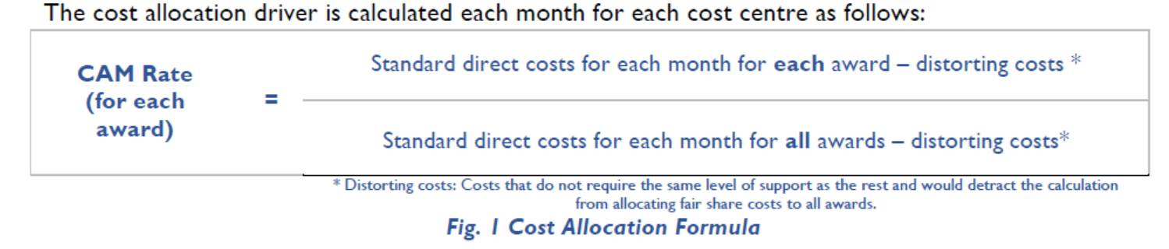

|  |  |  |
| --- | --- | --- |
|  |  |  |
|  | | |
|  | | |

Considerations for the calculation of the CAM Rate include the following:

a) Standard Direct Costs: Costs that are directly charged to an award (or a group of awards). Costs incurred for a particular activity and directly benefiting a specific award (or multiple-awards). This includes all project activities and operational costs related to project objectives. For costs charged to multiple awards, a specific computation or basis to determining how to attribute a share of the cost will be used.